Colegio Nacional Dr. Arturo U. Illia - UNMdP

13
Road Safety
B.O.W. Workshop
Palacios, Joaquín E. – Vega, Julián – Vekselman, Alan

Statistics show that road accidents are the number one cause of death of people between the ages 5 to 30. In Argentina, this is a huge problem because most citizens have a reckless way of driving, not caring about the law or the pedestrian’s safety. Besides, a lot of people drink and drive, causing injuries and even death to other people and to themselves. Most of the victims of the accidents that take place in the most developed countries are not the drivers but the pedestrians and bicyclists and all of the inhabitants using other sorts of vehicles.
Global Statistics:
Every year, more than 1.17 million people die in road accidents around the world. About 70 percent of these deaths occur in developing countries. 65 percent of the deaths involve pedestrians and 35 percent of the pedestrian deaths are children. Annually, more than ten million citizens are victims of road accidents, causing serious injuries and even death. It is important to realize which action needs to be taken to prevent more people from continuing being reckless towards the law.
National Statistics:
In Argentina, the estimated number of deaths in traffic accidents is 12.6 for every 100.000 citizens, and it is the second lowest in South America after ^{Chile}, according to a report ciphers. The World Health Organization (WHO) has placed Argentina among the countries with a low level of mortality due to road accidents.
Local Statistics:
According to the Intentional Crime Prosecutor's Office, the number of road accidents resulting in dead victims has diminished in almost 50 percent in Mar del Plata since last year. Moreover, in the last two years, the rate of people driving with a higher alcohol level in blood than the allowed was reduced from 16 percent to the 5.5 percent
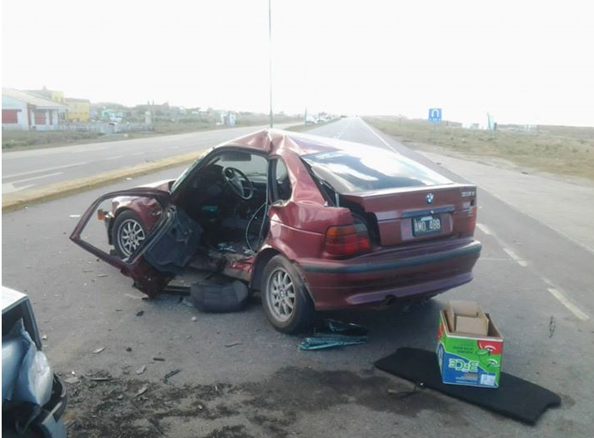
In 2012, in Mar del Plata, 25 road accidents with fatal victims were registered. The cipher diminished in a 50% in relation with 2011, when there were 45 deadly road accidents registered. 39% of these accidents had a motorcycle involved. There were 58% people older than 60 years and 68% of the injured were younger than 25 years old. In all, thanks to the accident prevention projects, the number of accidents diminished by a 10% during the last years.

Recent fatal accident in route 11 near Mar del Plata. One death and one injured.

Chart showing the reduction of accidents. Periods compared: 2010-2012 with 2007-2009 in Mar del Plata.

Type of accident | Cipher reduced
With victims | 11.3%
Mildly Injured | 27.2%
Badly Injured | 16.5%
Fatal victims | 34.3%

In conclusion, it is important to be aware of this growing danger and to respect not only the persons around us, but also ourselves. Although there are projects to reduce the number of accidents, and many of them have been successful, the best way of doing it is by making the society conscious of the weapon that a vehicle can represent. Reckless drivers and thoughtless pedestrians have to change their way of thinking so that we can make our country and our world a better place to walk through safely.

Bibliography
Fuente: Dyn. “En Argentina hay un promedio de 21 muertos por día en accidentes de tránsito”. Clarin. 09/06/13. http://www.clarin.com/sociedad/Argentina-promedio-muertos-accidentes-transito_0_934707088.html (Consultado el 9 de octubre de 2013).
Fuente: Alejandro Aníbal García. “El problema del tránsito en Mar del Plata”. La Capital. 30/10/11. http://www.lacapitalmdp.com/noticias/La-Ciudad/2011/10/31/199544.htm (Consultado el día 9 de octubre de 2013).
Autor desconocido. “Los accidentes de tránsito son la primera causa mundial de muerte entre jóvenes de 15 a 29 años”. Onu.org.ar. 14/03/13. http://www.onu.org.ar/View.aspx?354 (Consultado el 9 de octubre de 2013).
Autor desconocido. “Violento choque en ruta 11: Un muerto y un herido”. Diario 0223. 09/08/2013. http://www.0223.com.ar/k/2013-8-9-violento-choque-en-ruta-11-dos-personas-hospitalizadas (Consultado el 9 de octubre de 2013).
Autor desconocido. “Road Safety”. http://www.worldbank.org/transport/roads/safety.htm#crash (Consultado el 9 de octubre de 2013).
Autor desconocido. “En un año bajaron casi un 50% los accidentes de tránsito con víctimas fatales en la ciudad”. La Capital. 16/06/2013. http://www.lacapitalmdp.com/noticias/La-Ciudad/2013/06/17/244043.htm (Consultado el 9 de octubre de 2013).

Index:
Global Statistics: 1
National Statistics: 1
Local Statistics: 1
Bibliography 2

